LAB 2:

Note; I Have taken help from chatgpt and some of the codes through w3schools. I researched a lot to make best version of my code.

**Section A: Design and GUI (120 Marks)**

* + 1. Create a new JavaFX application project in your chosen Java IDE.
    2. Name the project using your name.
    3. Design the GUI interface for your JavaFX application, including a Table View, Buttons such as Insert, Update, Delete, and View Data to display data from the MySQL database tables and input fields for CRUD operations.
    4. Take a screenshot of your GUI layout, ensuring it includes your name, student ID, and date.

This is just code full code is in git

// Input fields

TextField idField = new TextField();

idField.setPromptText("ID");

TextField nameField = new TextField();

nameField.setPromptText("Name");

// Buttons

Button insertBtn = new Button("Insert");

Button updateBtn = new Button("Update");

Button deleteBtn = new Button("Delete");

Button viewBtn = new Button("View Data");

// Arrange input fields horizontally

HBox inputFields = new HBox(10, idField, nameField);

// Arrange buttons horizontally

HBox buttonRow = new HBox(10, insertBtn, updateBtn, deleteBtn, viewBtn);

// Combine all in a vertical layout

VBox layout = new VBox(15, inputFields, buttonRow);

layout.setStyle("-fx-padding: 20;");

// Display the scene

Scene scene = new Scene(layout, 500, 200);

primaryStage.setTitle("Niraj Bhandari - StudentID123456 - July 6, 2025");

primaryStage.setScene(scene);

primaryStage.show();

1. A screenshot of a computer

   AI-generated content may be incorrect.

**Section B: Database Connection (180 Marks)**

* + 1. Implement the database connection code in your JavaFX application.

private Connection connect() throws SQLException {

return DriverManager.getConnection(URL, USER, PASSWORD);

}

* + 1. Ensure it includes the necessary database URL, username, and password.

private final String URL = "jdbc:mysql://localhost:3306/studentdb";

private final String USER = "root";

private final String PASSWORD = "";

* + 1. Take a screenshot of the code where you establish the database connection.

**Section C: Data Models and ORM (120 Marks)**

* + 1. Create Java classes that represent the structure of your database tables.
    2. These classes will be used to model the data you retrieve from and insert into the database.
    3. Use Object-Relational Mapping (ORM) techniques to simplify database interactions.A screen shot of a computer program

       AI-generated content may be incorrect.

**Section D: Open JDBC Jar (120 Marks)**

* + 1. Download and include the appropriate JDBC driver (for example, MySQL Connector/J) in your project.
    2. Ensure that your project's build path includes the JDBC driver JAR file.

**Section E: Load Data in Table View (120 Marks)**

* + 1. Write code to retrieve data from the MySQL database tables and load it into the Table View component.
    2. Implement an event handler to trigger this action on button click.
    3. A screen shot of a computer code

       AI-generated content may be incorrect.

**Section F: Insert Data into Database (120 Marks)**

* + 1. Write code to insert data into the database when a button is clicked.
    2. Ensure that the input fields on the GUI are used to gather data for insertion.

**Section G: Update Data in Database (120 Marks)**

* + 1. Write code to update existing data in the database when a button is clicked.
    2. Allow the user to provide an ID to identify the data to update.
    3. 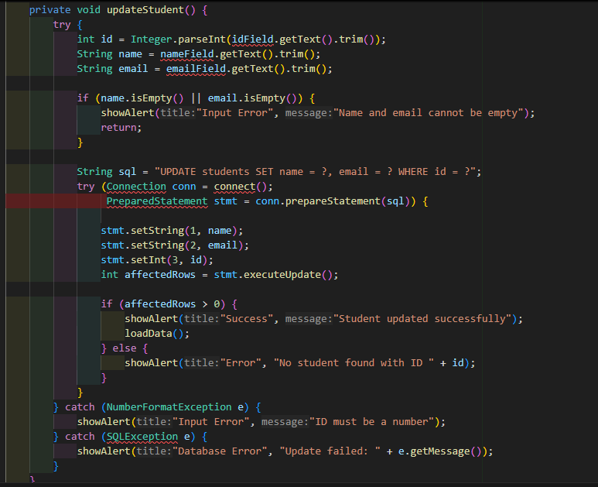

**Section H: Delete Data from Database (120 Marks)**

* + 1. Write code to delete data from the database when a button is clicked.
    2. Provide the option for the user to specify an ID for data deletion.

Section B:-

-- Create the database

CREATE DATABASE studentdb;

-- Switch to the new database

USE studentdb;

-- Create the students table

CREATE TABLE students (

id INT PRIMARY KEY,

name VARCHAR(50),

email VARCHAR(50)

);

-- Insert the sample records

INSERT INTO students (id, name, email) VALUES

(1, 'Alice Sharma', 'alice@example.com'),

(2, 'Bikash Thapa', 'bikash@example.com'),

(3, 'Sita Rana', 'sita.rana@example.com'),

(4, 'Ram Karki', 'ram.karki@example.com'),

(7, 'Saroj', 'saroj089@gmail.com');

